Name: Kadiyala Naresh

Rg.no.: 192110312

Course: object oriented C++

Code: DSA0163

**Code:**

#include<iostream>

using namespace std;

class A{

public:

int a;

A(){

a=10;

}

~A(){

cout<<"obj.destructed";

}

void show(){

cout<<a;

}

};

int main(){

A*A1=new A();

A1;

delete A1;

}

Output:

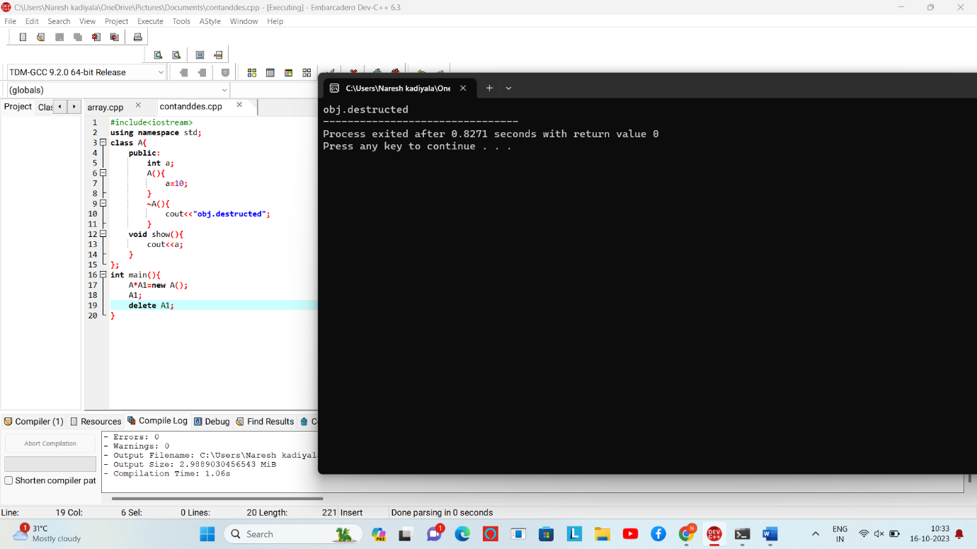

**2.Array of object code**:

#include<iostream>

using namespace std;

class A{

public:

int a;

A(){

cout<<"Enter the values: ";

cin>>a;

}

~A(){

cout<<"object destrenced";

}

void show(){

cout<<a;

}

};

int main(){

A A1[3];

A1[0].show();

A1[1].show();

A1[2].show();

}

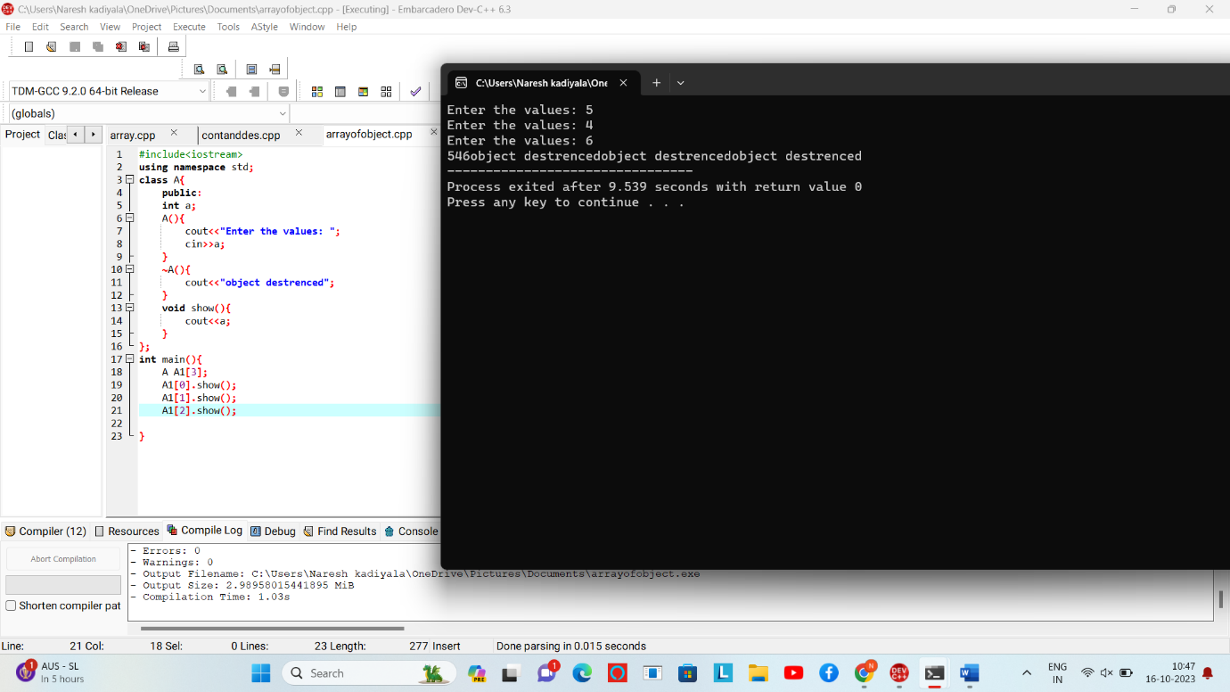

**3.code**:

#include<iostream>

using namespace std;

class A{

public:

int n;

A(){

cout<<"Enter a values: ";

cin>>n;

}

~A(){

cout<<"object is destructed";

}

void show(){

cout<<n;

}

};

int main(){

int n;

A*p=new A[n];

for(int i=0;i<n;i++){

(p+i);

}

delete[]p;

}

